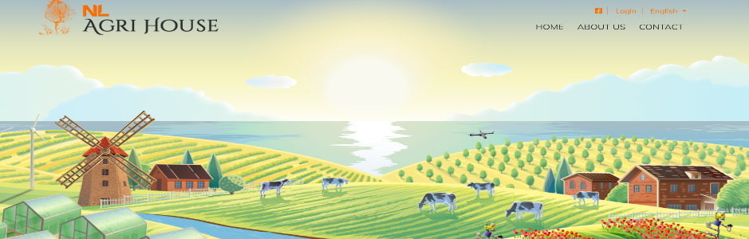
NAME OF THE COMPANY*

LOGO - please attach your company logo to the email message when returning the filled in form*

HEADQUARTERS*:
Address:

Contact:__________________________________________________________________
Person:
Email:

Phone:

Website:

Twitter page (if applicable):

ROMANIAN REPRESENTATIVE (if applicable):
Company name and address:

Contact:__________________________________________________________________
Person:
Email:

Phone:

Website:

NOTE: For the following fields, you can write both in English AND Romanian, if possible. Please note that in case you provide an English text only, we shall ensure the translation into Romanian. However, we cannot provide guarantees for the full accuracy of the technical terms used.

Domenii de activitate (va rugam bifati TOATE domeniile in care activeaza compania dvs.)  Horticultură în spații protejate:  ☐ Sere / solarii  ☐ Echipamente pentru sere / solarii  ☐ Semințe și material săditor  ☐ Produse pentru protecția plantelor  ☐ Substraturi, îngrășăminte și alte inputuri  ☐ Depozitare, sortare, ambalare, transport legume / fructe  ☐ Consultanță / tehnologii  Pomicultură:  ☐ Material săditor. Pomi fructiferi  ☐ Mașini și echipamente pentru livezi (plantare, întreținere, recoltare)  ☐ Produse pentru protecția plantelor  ☐ Îngrășăminte și alte inputuri  ☐ Depozitare, sortare, ambalare, transport fructe  ☐ Procesare fructe  ☐ Consultanță / tehnologii  Sector lapte:  ☐ Vaci și material genetic  ☐ Furaje, concentrate, premixuri  ☐ Utilaje și echipamente pentru ferme de vaci  ☐ Stocare, refrigerare și transport lapte  ☐ Procesare lapte  ☐ Consultanță pentru creșterea vacilor cu lapte / tehnologii  Flori, plante ornamentale, peisagistică:  ☐ Furnizori flori  ☐ Furnizori plante ornamentale  ☐ Furnizori arbori și arbuști  ☐ Furnizori semințe și material săditor  ☐ Furnizori inputuri pentru floricultură / arboricultură  ☐ Echipamente pentru floricultură / arboricultură  ☐ Servicii de peisagistică / consultanță  Alte sectoare:  ☐ Utilaje, echipamente și unelte agricole  ☐ Creșterea porcilor - material genetic, nutriție, echipamente și inputuri  ☐ Creșterea păsărilor - material genetic, nutriție, echipamente și inputuri  ☐ Creșterea animalelor (altele)  ☐ Piscicultură  ☐ Produse de uz veterinar  ☐ Inputuri agricole (nespecificate anterior)  ☐ Utilaje, echipamente și inputuri pentru industria alimentară  ☐ Comerț cu produse agro-alimentare  ☐ Energie regenerabilă - tehnologii, soluții  ☐ Gestionarea apei  ☐ Consultanță (nespecificată anterior)  ☐ Alte sectoare (nespecificate anterior) | Company activities (please tick ALL the activities which apply to your company)  Protected horticulture:  ☐ Greenhouses / plastic tunnels  ☐ Equipment for greenhouses / plastic tunnels  ☐ Seeds and planting material  ☐ Plant protection products  ☐ Substrates, fertilisers and other inputs  ☐ Storage, sorting, packaging, transport - vegetables / fruits  ☐ Consultancy / technologies  Fruit sector:  ☐ Planting material. Fruit trees  ☐ Equipment and machinery for fruit growing (planting, maintenance, harvesting)  ☐ Plant protection products  ☐ Fertilisers and other inputs  ☐ Storage, sorting, packaging, transport - fruits  ☐ Fruit processing  ☐ Consultancy / technologies  Dairy sector:  ☐ Cows and genetic material  ☐ Feed, concentrates, premixes  ☐ Machinery and equipment for dairy farms  ☐ Storage, cooling and transport of milk  ☐ Milk processing  ☐ Consultancy / technologies - dairy  Flowers, ornamentals & landscaping:  ☐ Flower suppliers  ☐ Ornamental plants suppliers  ☐ Trees and shrubs suppliers  ☐ Seed and planting material suppliers  ☐ Input suppliers for floriculture /  arboriculture  ☐ Equipment for floriculture / arboriculture  ☐ Landscaping / consultancy services  Other sectors:  ☐ Agricultural machinery, equipment and tools  ☐ Pig farming - genetic material, nutrition, equipment and inputs  ☐ Poultry farming - genetic material, nutrition, equipment and inputs  ☐ Livestock farming (others)  ☐ Fish farming  ☐ Veterinary products  ☐ Agricultural inputs (not previously specified)  ☐ Machinery, equipment and inputs for the food industry  ☐ Trade in agri-food products  ☐ Renewable energy - technologies, solutions  ☐ Water management  ☐ Consultancy (not previously specified)  ☐ Other sectors (not previously specified)

ABOUT THE COMPANY*/DESCRIEREA COMPANIEI:
[SUMMARY - please summarize below, in maximum 10-12 rows, the main info about your company’s activity]

ABOUT THE COMPANY / DESCRIEREA COMPANIEI *:
[LONG DESCRIPTION - please add a detailed text about your company - maximum 2 pages]

PRODUCT 1 / PRODUS 1*:
(please add name of the 1st product you want to list on the website)

DESCRIPTION OF PRODUCT 1 *: (please add a description of your product of maximum 2 pages)

PRODUCT 2 / PRODUS 2*:
(please add name of the 1st product you want to list on the website)

DESCRIPTION OF PRODUCT 2 *: (please add a description of your product of maximum 2 pages)

PRODUCT 3 / PRODUS 3*:
(please add name of the 1st product you want to list on the website)

DESCRIPTION OF PRODUCT 3 *: (please add a description of your product of maximum 2 pages)

PHOTOS OF PRODUCTs: (please attach to the email, together with the completed form, a maximum of 3 pictures / product. Every picture should have a relevant name (including company name, product name and picture number: 1, 2 or 3). 9 pictures in total. Each picture shall have at least 1000 x 1000 pixels and shall not exceed 10MB each).
* Mandatory fields

GDPR NOTE:
The above information will be collected and used by The Netherlands Embassy in Romania and its partners, only with the purpose of listing your company and products on the website http://agrihousenl.ro/.

